**Name: B.Sai Hithesh**

**USN: 1BM17CS021**

**Program Number :**

**Program Title : IR sensor controlling servo motor.**

**AIM: Servo motor starts to rotate whenever button is pressed on remote.**

**Hardware Required:**

* **Arduino Board**
* **IR sensor**
* **IR remote**
* **Breadboard**
* **Servo motor**

**Circuit Diagram:**

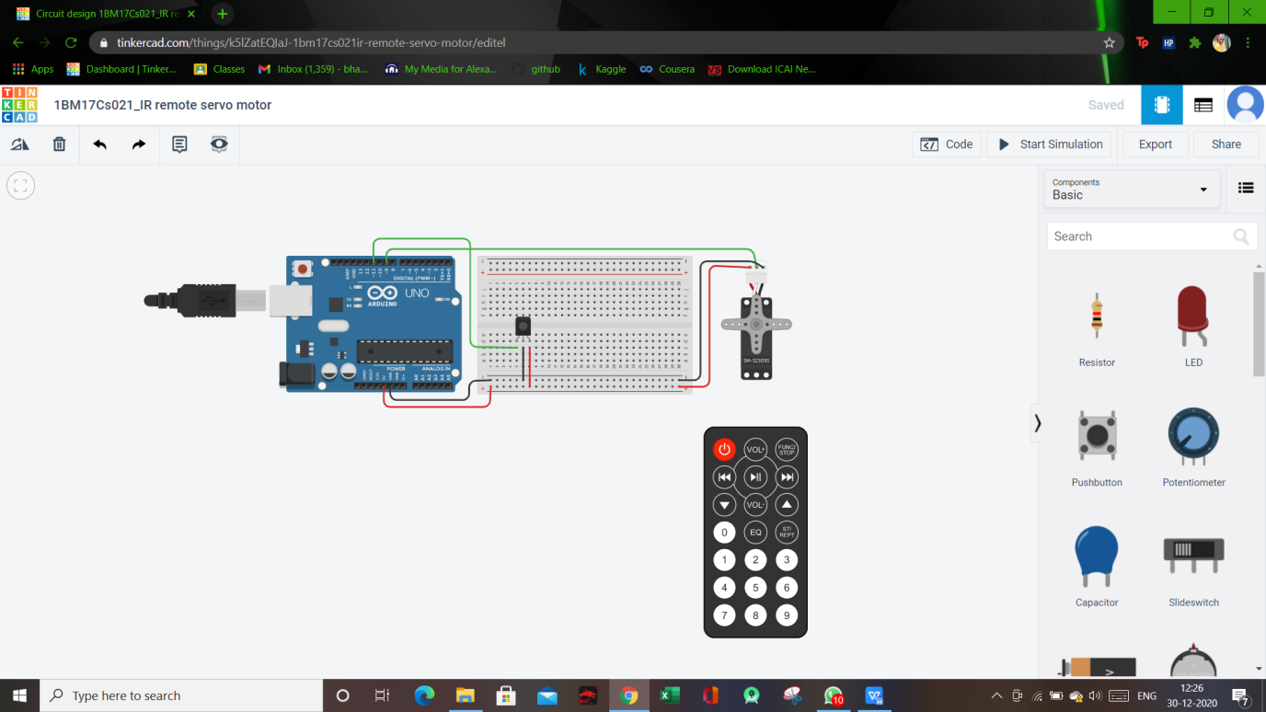

**Circuit diagram along with code:**

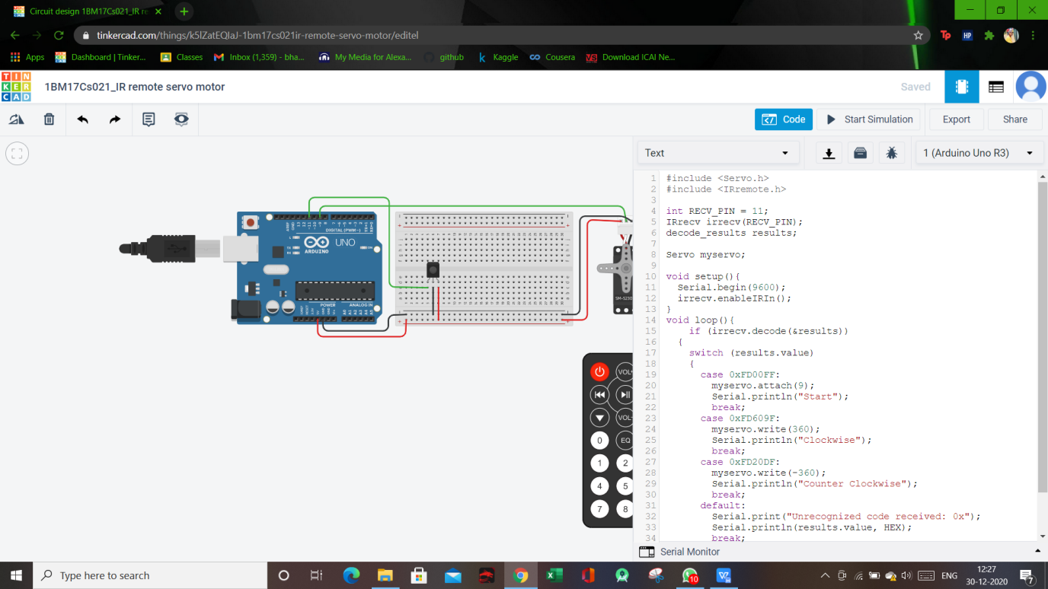

**Simulation:**

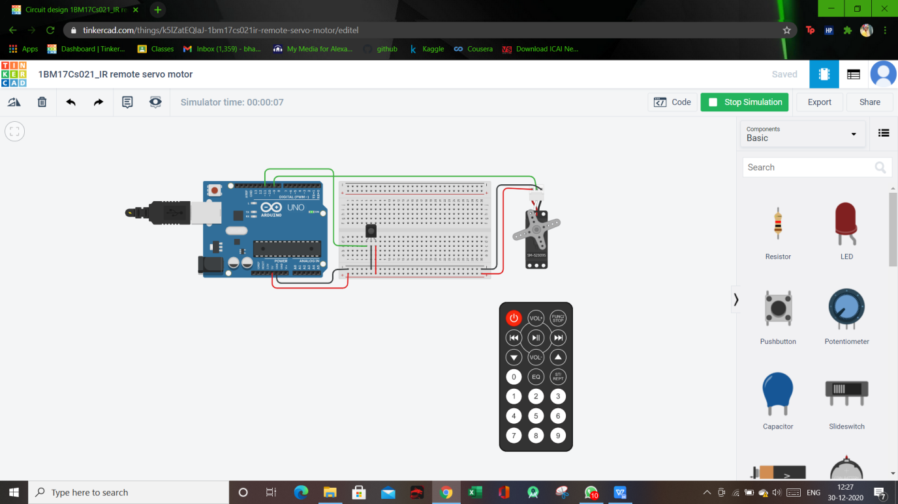

**Code:**

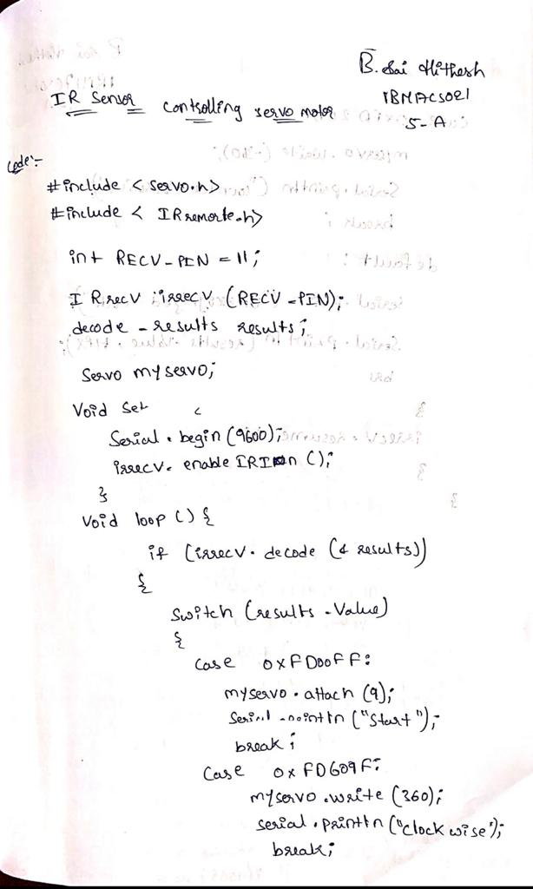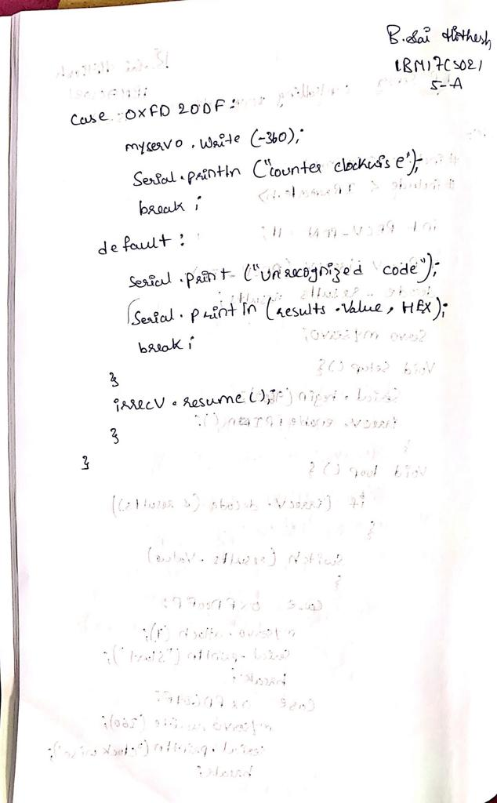

**Observation/output: Motor starts to rotate whenever button is pressed on IR remote.**